|  |  |
| --- | --- |
| NAME: _____________ | **Stats and probability** |
| Quiz 4-6 – Compound Probability | **DATE: Thursday, May 18, 2017** |

The chance that a driver in Maine wears a seatbelt is 85%. If you look at 3 drivers on the road, find probability:

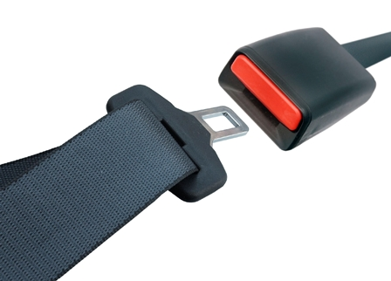

|  |  |
| --- | --- |
| P(all 3 wearing seatbelt): | P(none are wearing seatbelt): |
| P (at least one is not wearing seatbelt): | Challenge:  P(exactly one is wearing a seatbelt): |

There are 9 girls and 12 boys in this class:

Im going to give extra credit to 2 and Im going to pick randomly:

Find:

|  |  |
| --- | --- |
| P (all girls) | P (all boys) |
| P (one girl and one boy) | Challenge: If I pick 3 students randomly from the class:  P (1 girl, 2 boys) |